**Graphical Analysis of the University of California**

STA 141A HW#3

Hiu Man(Stephanie) Lam

**HONOR CODE**

The analysis derived by using the codes attached in appendix constitutes my own work. I have consulted the following resources regarding this assignment:

Samuel Kadin, Ryan Kuan, Meixin Deng, Sooyeon Park and Qiwen Guan.

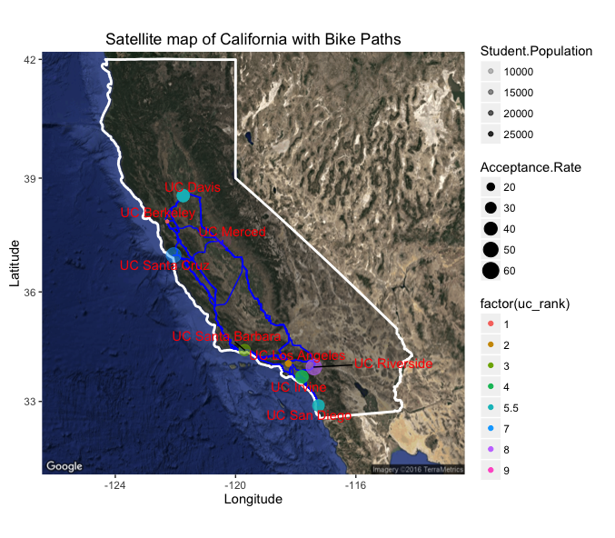

This graph virtualizes the 9 different University campuses in California and the bike paths between each of the UC’s. The size of the dots represents UC’s acceptance rate for each UC while the colors represents the ranking within the UC system. It appears that UC Riverside has the highest acceptance rate and UC Berkeley ranks the 1st among the 9 universities. The shading of the dots also represents student population and UC Merced has the smallest because it has very light shading. I also found interesting that there is only one bike path between UC Irvine and UC San Diego, which means that the path is overlapped.

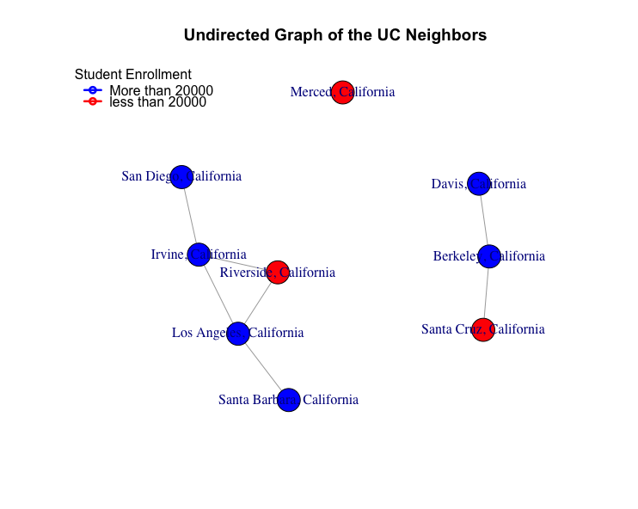

The undirected graph above shows the driving distance between each pair of campuses that is less than 100 miles. The edge between the dots means that the two cities are neighbors. The color of dot represents the number of student enrollment: red color represents that the UC has less than 20,000 students and blue represents that the campus has greater than 20,000 students. We can also see that Merced is far away from all the other UC.